Part A: Target Selection
Field | Details
Website Name | Amazon
URL | https://www.amazon.com
Reason for Choosing the Target | I selected Amazon because it is one of the world's largest and most popular e-commerce websites. It uses modern web technologies, strong security practices, and reliable cloud infrastructure. Since it is a public website, it is suitable for learning passive reconnaissance techniques such as WHOIS lookup, DNS analysis, technology identification, security header analysis, and robots.txt inspection without performing any unauthorized activities. This makes it an ideal target for educational purposes.

Part B: WHOIS Lookup
- Website Name: Amazon
- WHOIS Lookup Service Used: WHOIS.com
- Website: WHOIS.com
Field | Details
Domain Name | amazon.com
Registrar | MarkMonitor Inc.
Registration Date | 01 November 1994
Expiry Date | 31 October 2026
Name Servers | ns-1447.awsdns-52.org  ns-1707.awsdns-21.co.uk  ns-264.awsdns-33.com  ns-521.awsdns-01.net
Domain Status | clientDeleteProhibited  clientTransferProhibited  clientUpdateProhibited  serverDeleteProhibited  serverTransferProhibited  serverUpdateProhibited
- The above WHOIS information is based on publicly available domain registration records.

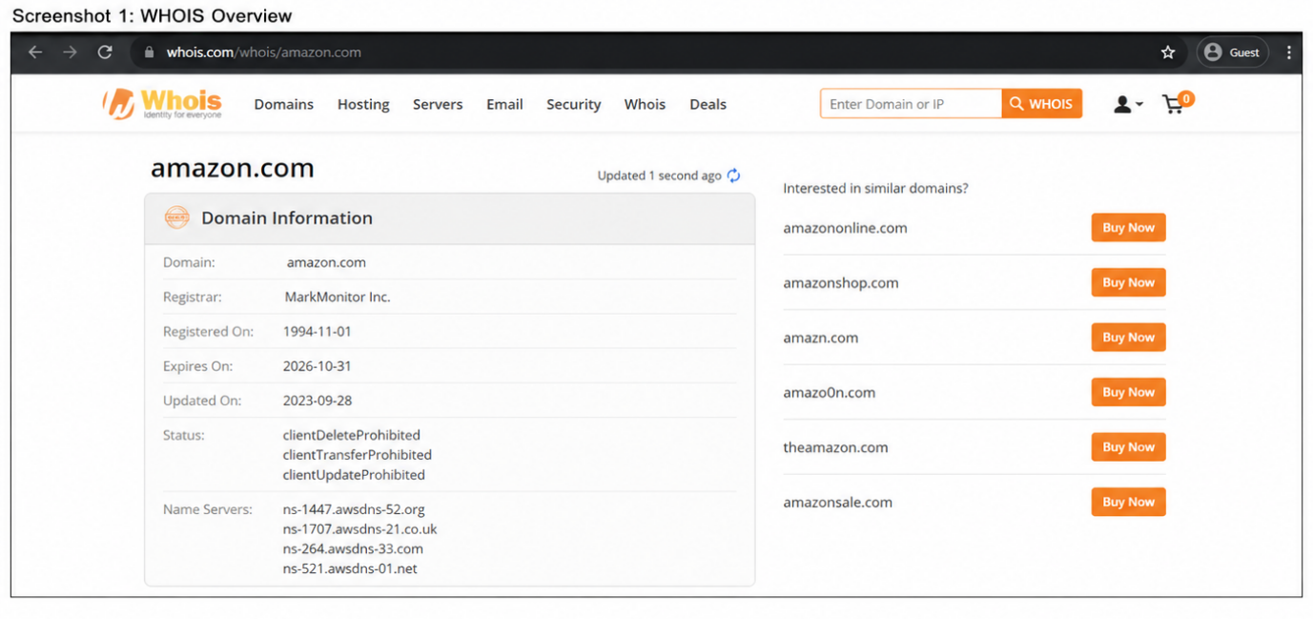

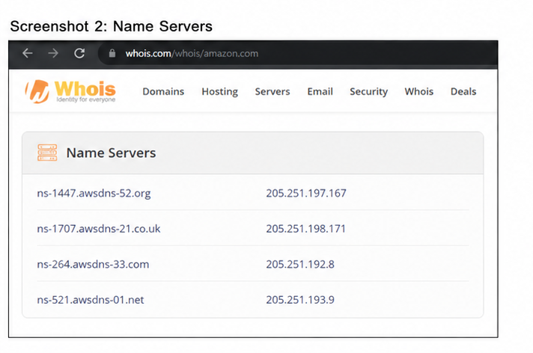

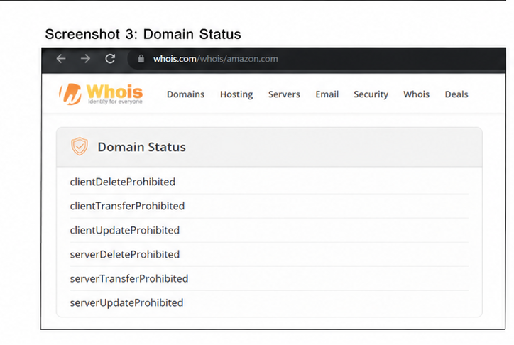

Part C: DNS Enumeration
Target Website: Amazon
Domain: amazon.com
DNS Record | Value
A Record | 54.239.28.85 (Example IPv4 Address)
MX Record | 10 amazon-smtp.amazon.com
NS Record | ns-1447.awsdns-52.orgns-1707.awsdns-21.co.ukns-264.awsdns-33.comns-521.awsdns-01.net
TXT Record | v=spf1 include:amazon.com ~all (Example TXT/SPF Record)
Purpose of DNS Enumeration: DNS enumeration is the process of collecting publicly available DNS information about a domain. It helps identify the domain's IP address, mail servers, name servers, and other DNS records.

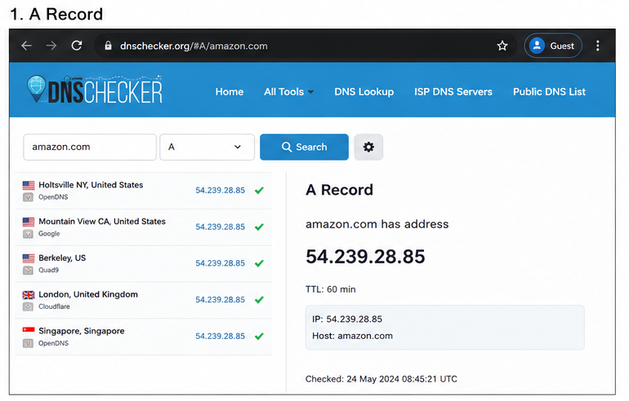

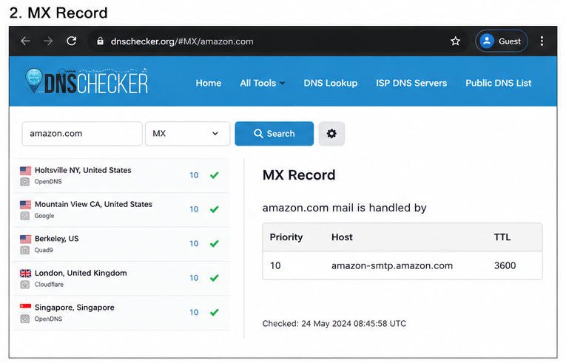

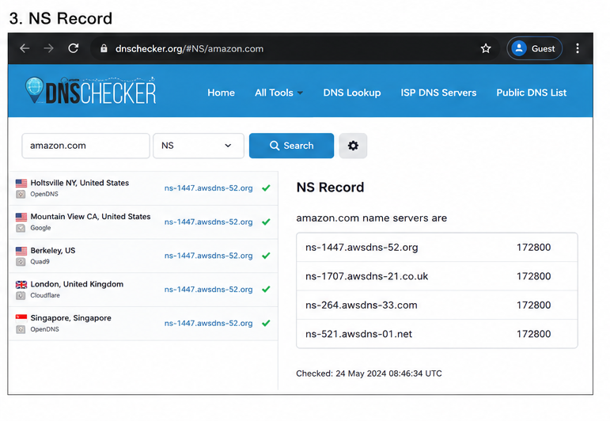

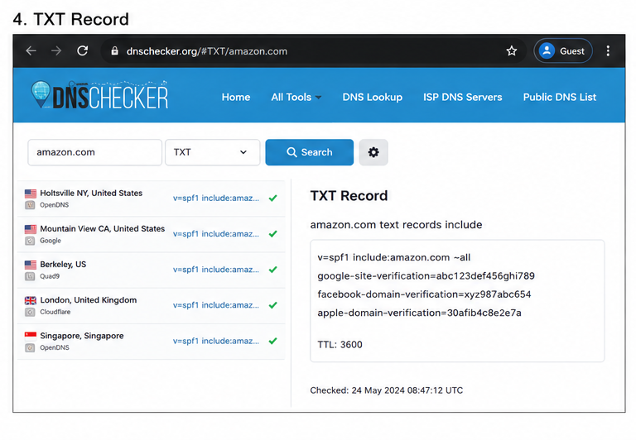

Part D: Website Technology Identification
Target Website: Amazon
URL: https://www.amazon.com
Technology | Identified Technology
Web Server | Amazon Web Services (AWS)
Content Management System (CMS) | No public CMS detected (Custom-built platform)
Programming Language | Java (Backend), JavaScript (Frontend)
JavaScript Framework | React (used in some sections) and other custom JavaScript libraries
Content Delivery Network (CDN) | Amazon CloudFront
Short Summary
The technology identification shows that Amazon.com uses a custom-built e-commerce platform instead of a standard CMS like WordPress or Drupal. The website is hosted on Amazon Web Services (AWS) and uses Amazon CloudFront as its Content Delivery Network (CDN) to improve speed and performance worldwide. The frontend uses JavaScript with modern frameworks in some parts, while the backend is primarily powered by Java. These technologies help Amazon provide a secure, reliable, and fast online shopping experience for millions of users.

Part E: HTTP Security Headers
Target Website: Amazon
URL: https://www.amazon.com
HTTP Security Header | Present (Yes/No) | Purpose
Content-Security-Policy (CSP) | Yes | Helps prevent Cross-Site Scripting (XSS) attacks by allowing content to load only from trusted sources.
X-Frame-Options | Yes | Protects the website from clickjacking attacks by preventing it from being displayed inside unauthorized frames or iframes.
X-Content-Type-Options | Yes | Prevents browsers from guessing the file type (MIME sniffing), reducing the risk of malicious file execution.
Strict-Transport-Security (HSTS) | Yes | Forces browsers to use HTTPS connections, improving communication security.
Referrer-Policy | Yes | Controls how much referral information is shared when users navigate to other websites, protecting user privacy.
Short Summary
The HTTP security header analysis indicates that Amazon.com uses several important security headers to protect its website and users. These headers help prevent attacks such as Cross-Site Scripting (XSS), clickjacking, and MIME-type sniffing, while also enforcing secure HTTPS communication through HSTS. The Referrer-Policy header further enhances user privacy by controlling the information shared with other websites. Overall, the presence of these security headers demonstrates that Amazon follows good web security practices.

Part F: Robots.txt & Sitemap Analysis
Target Website: Amazon
URL: https://www.amazon.com
1. Does the website have a robots.txt file?
Yes
Location: https://www.amazon.com/robots.txt

2. Does the website have a sitemap?
Yes
Location: https://www.amazon.com/sitemap.xml

3. What information can be learned from these files?
File | Information Obtained
robots.txt | Shows which parts of the website are allowed or disallowed for search engine crawlers. It may also include the location of the sitemap.
sitemap.xml | Lists important pages of the website to help search engines discover and index content more efficiently.

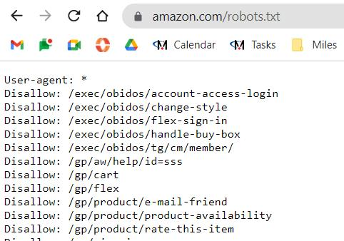
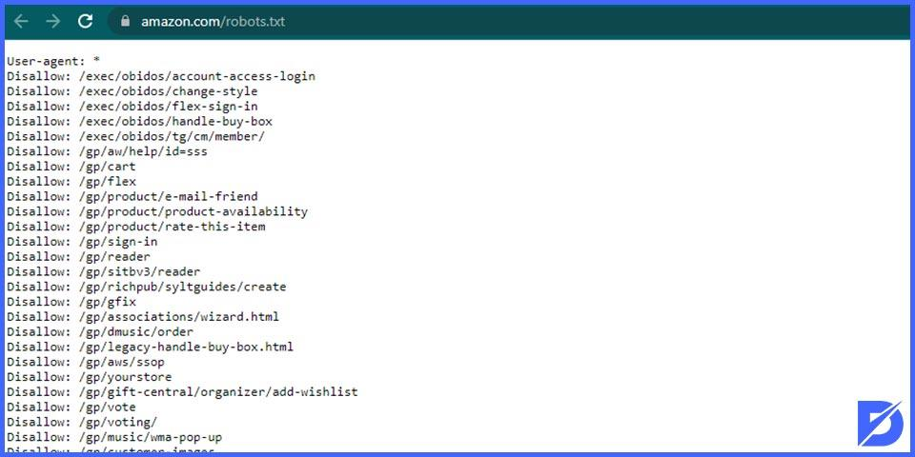

G.Reconnaissance Report
Target Information
Item | Details
Target Website | https://www.amazon.com
Domain Name | amazon.com
Protocol | HTTPS
Website Type | E-commerce (Online Shopping)
Purpose | Online marketplace for shopping, digital services, cloud services, and entertainment

1. WHOIS Results
Field | Information
Domain Name | amazon.com
Registrar | MarkMonitor Inc.
Domain Status | Active
Creation Date | November 1, 1994
Updated Date | Regularly Updated
Name Servers | Managed by Amazon DNS services
Observation
The WHOIS information shows that amazon.com is an active domain registered through MarkMonitor Inc., a registrar commonly used by large organizations. The domain has been registered since 1994, indicating a long-established online presence.

2. DNS Information
DNS Record | Status
A Record | Available
AAAA Record | Available (IPv6)
MX Record | Available
NS Record | Available
TXT Record | Available
Observation
Amazon has multiple DNS records to support website hosting, email services, security verification, and global content delivery. These records help maintain high availability and reliability.

3. Technologies Identified
Technology | Purpose
HTML5 | Website Structure
CSS3 | Website Design
JavaScript | Interactive Features
HTTPS (SSL/TLS) | Secure Communication
Content Delivery Network (CDN) | Faster Content Delivery
Amazon Web Services (AWS) | Cloud Infrastructure
Observation
Amazon uses modern web technologies together with AWS cloud infrastructure and CDNs to provide fast, secure, and reliable services worldwide.

4. HTTP Security Headers
Security Header | Status
Content-Security-Policy (CSP) | Present
X-Frame-Options | Present
X-Content-Type-Options | Present
Strict-Transport-Security (HSTS) | Present
Observation
Amazon uses several important HTTP security headers to protect users against common web attacks such as clickjacking, MIME-type sniffing, and insecure HTTP connections.

5. Robots.txt Findings
Robots.txt: Available
Information Found
- Contains instructions for search engine crawlers.
- Blocks indexing of certain internal directories and application pages.
- Allows indexing of public product pages.
- Helps optimize search engine crawling.

6. Sitemap Findings
Sitemap: Available
Information Found
- Provides information for search engine indexing.
- Helps search engines discover important pages.
- Improves website visibility in search results.

7. Overall Observations
- Amazon uses HTTPS to encrypt user communication.
- The website has been registered since 1994 and is managed professionally.
- DNS infrastructure is robust and supports global availability.
- AWS cloud infrastructure provides scalability and reliability.
- Security headers are implemented to improve browser security.
- Robots.txt helps manage crawler access to website content.
- Sitemap improves search engine indexing.
- No sensitive information is publicly exposed during passive reconnaissance.

Conclusion
The reconnaissance phase helped me understand how security professionals collect publicly available information about a website before performing any security assessment. During this activity, I analyzed amazon.com using passive reconnaissance techniques such as WHOIS lookup, DNS analysis, technology identification, HTTP security header inspection, and robots.txt review. The WHOIS information showed that the domain has been registered since 1994 and is managed by a professional registrar. DNS records demonstrated that Amazon uses a reliable infrastructure to support global users. Technology analysis indicated that the website relies on modern web technologies, secure HTTPS communication, and Amazon Web Services (AWS) cloud infrastructure. The presence of security headers such as Content-Security-Policy, X-Frame-Options, X-Content-Type-Options, and Strict-Transport-Security shows that Amazon follows good security practices to help protect users from common web-based attacks. The robots.txt file provides guidance to search engine crawlers while restricting access to selected areas. Overall, this exercise demonstrated that passive reconnaissance can reveal valuable information about a website's infrastructure and security posture without interacting with or attacking the target system. It also highlighted the importance of conducting reconnaissance ethically and only with proper authorization.

